Inception module V2

0. Environment

|  |  |
| --- | --- |
| DataSet | CIFAR-10 |
| Language | Python3.5 & Tensorflow 1.0 |
| optimizer | Adam |
| Loss function | Cross entropy Loss |

Input : 32x32x3 size image

1. initialize

|  |  |
| --- | --- |
| layer | max_pool(stride = 2, pool_size = 2, pad) |
| output | 16x16x3 |
| layer | 1x1 conv (filter = 64) |
| output | 16x16x64 |

2. module (10 times)

|  |  |  |  |  |
| --- | --- | --- | --- | --- |
| layer | 1x1 conv  (fileter = 16) | 3x3 conv  (filter = 16, pad) | 3x3 conv  (filter = 16, pad) | 1x1 conv  (filter = 16, pad) |
| 3x3 conv  (filter = 16, pad) |
| max_pool  (size = 3x3, pad) |
| output | 16x16x16 | 16x16x16 | 16x16x16 | 16x16x16 |
| concatenate | 16x16x64 | | | |
| Layer | relu | | | |
| output | 16x16x64 | | | |

3.Fully connected

|  |  |
| --- | --- |
| layer | Affine (W = 16x16x64,1024) |
| output | 1024 |
| layer | Affine (W = 1024, 10) |
| output | 10 |

4. Overall

|  |  |
| --- | --- |
| Training(7600 iteration) | Time : 7791.720436096191 seconds |
| Accuracy : 0.61 |
| Validation | Accuracy : 0.579 |
| Re-training(64 iteration) | Accuracy : 0.628 |
| Re-Validation | Accuracy : 0.579 |
| Test | Acurracy : 0.587 |

Training

Iteration 0: with minibatch training loss = 29.1 and accuracy of 0.19

Iteration 100: with minibatch training loss = 2.13 and accuracy of 0.2

Iteration 200: with minibatch training loss = 1.76 and accuracy of 0.34

Iteration 300: with minibatch training loss = 1.51 and accuracy of 0.42

Iteration 400: with minibatch training loss = 1.66 and accuracy of 0.38

Iteration 500: with minibatch training loss = 1.51 and accuracy of 0.53

Iteration 600: with minibatch training loss = 1.54 and accuracy of 0.53

Iteration 700: with minibatch training loss = 1.69 and accuracy of 0.41

Epoch 1, Overall loss = 3.17 and accuracy of 0.36

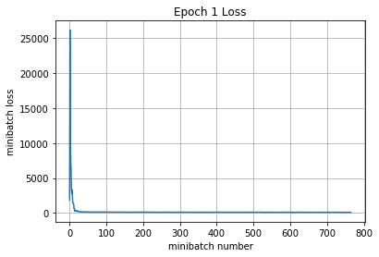

Iteration 800: with minibatch training loss = 1.48 and accuracy of 0.48

Iteration 900: with minibatch training loss = 1.45 and accuracy of 0.44

Iteration 1000: with minibatch training loss = 1.44 and accuracy of 0.5

Iteration 1100: with minibatch training loss = 1.57 and accuracy of 0.48

Iteration 1200: with minibatch training loss = 1.46 and accuracy of 0.47

Iteration 1300: with minibatch training loss = 1.49 and accuracy of 0.42

Iteration 1400: with minibatch training loss = 1.53 and accuracy of 0.42

Iteration 1500: with minibatch training loss = 1.65 and accuracy of 0.41

Epoch 2, Overall loss = 1.48 and accuracy of 0.464

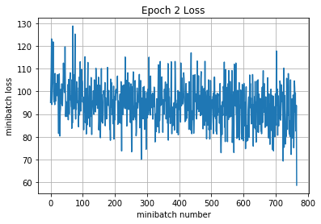

Iteration 1600: with minibatch training loss = 1.23 and accuracy of 0.55

Iteration 1700: with minibatch training loss = 1.41 and accuracy of 0.45

Iteration 1800: with minibatch training loss = 1.24 and accuracy of 0.52

Iteration 1900: with minibatch training loss = 1.43 and accuracy of 0.52

Iteration 2000: with minibatch training loss = 1.64 and accuracy of 0.36

Iteration 2100: with minibatch training loss = 1.42 and accuracy of 0.58

Iteration 2200: with minibatch training loss = 1.33 and accuracy of 0.53

Epoch 3, Overall loss = 1.39 and accuracy of 0.501

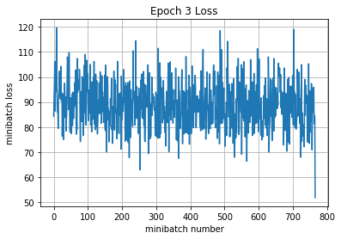

Iteration 2300: with minibatch training loss = 1.32 and accuracy of 0.55

Iteration 2400: with minibatch training loss = 1.25 and accuracy of 0.56

Iteration 2500: with minibatch training loss = 1.47 and accuracy of 0.38

Iteration 2600: with minibatch training loss = 1.27 and accuracy of 0.47

Iteration 2700: with minibatch training loss = 1.16 and accuracy of 0.62

Iteration 2800: with minibatch training loss = 1.26 and accuracy of 0.5

Iteration 2900: with minibatch training loss = 1.44 and accuracy of 0.44

Iteration 3000: with minibatch training loss = 1.7 and accuracy of 0.44

Epoch 4, Overall loss = 1.32 and accuracy of 0.523

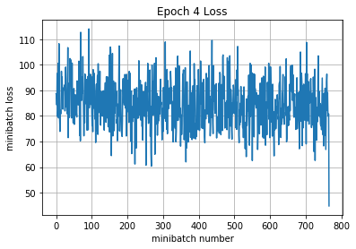

Iteration 3100: with minibatch training loss = 1.31 and accuracy of 0.48

Iteration 3200: with minibatch training loss = 1.24 and accuracy of 0.56

Iteration 3300: with minibatch training loss = 1.39 and accuracy of 0.52

Iteration 3400: with minibatch training loss = 1.17 and accuracy of 0.59

Iteration 3500: with minibatch training loss = 1.47 and accuracy of 0.44

Iteration 3600: with minibatch training loss = 1.18 and accuracy of 0.58

Iteration 3700: with minibatch training loss = 1.4 and accuracy of 0.5

Iteration 3800: with minibatch training loss = 1.2 and accuracy of 0.53

Epoch 5, Overall loss = 1.27 and accuracy of 0.542

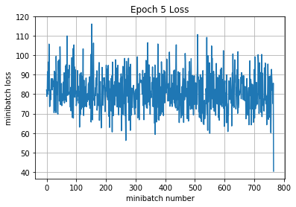

Iteration 3900: with minibatch training loss = 1.46 and accuracy of 0.53

Iteration 4000: with minibatch training loss = 1.17 and accuracy of 0.55

Iteration 4100: with minibatch training loss = 1.35 and accuracy of 0.41

Iteration 4200: with minibatch training loss = 0.993 and accuracy of 0.67

Iteration 4300: with minibatch training loss = 1.35 and accuracy of 0.56

Iteration 4400: with minibatch training loss = 0.982 and accuracy of 0.66

Iteration 4500: with minibatch training loss = 1.18 and accuracy of 0.59

Epoch 6, Overall loss = 1.23 and accuracy of 0.557

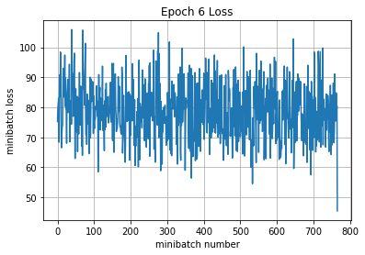

Iteration 4600: with minibatch training loss = 1 and accuracy of 0.61

Iteration 4700: with minibatch training loss = 1.34 and accuracy of 0.5

Iteration 4800: with minibatch training loss = 1.15 and accuracy of 0.64

Iteration 4900: with minibatch training loss = 1.24 and accuracy of 0.58

Iteration 5000: with minibatch training loss = 1.27 and accuracy of 0.61

Iteration 5100: with minibatch training loss = 1.24 and accuracy of 0.58

Iteration 5200: with minibatch training loss = 1.21 and accuracy of 0.62

Iteration 5300: with minibatch training loss = 1.19 and accuracy of 0.58

Epoch 7, Overall loss = 1.19 and accuracy of 0.575

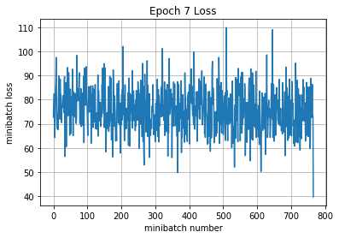

Iteration 5400: with minibatch training loss = 0.893 and accuracy of 0.64

Iteration 5500: with minibatch training loss = 1.19 and accuracy of 0.56

Iteration 5600: with minibatch training loss = 1.09 and accuracy of 0.61

Iteration 5700: with minibatch training loss = 1.16 and accuracy of 0.58

Iteration 5800: with minibatch training loss = 1.24 and accuracy of 0.62

Iteration 5900: with minibatch training loss = 1.12 and accuracy of 0.53

Iteration 6000: with minibatch training loss = 0.962 and accuracy of 0.62

Iteration 6100: with minibatch training loss = 1.2 and accuracy of 0.53

Epoch 8, Overall loss = 1.15 and accuracy of 0.589

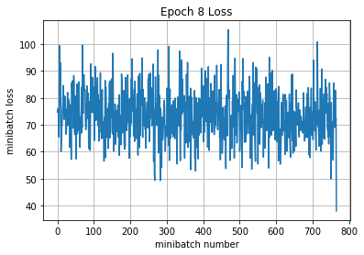

Iteration 6200: with minibatch training loss = 1.28 and accuracy of 0.55

Iteration 6300: with minibatch training loss = 0.949 and accuracy of 0.67

Iteration 6400: with minibatch training loss = 1.21 and accuracy of 0.59

Iteration 6500: with minibatch training loss = 0.959 and accuracy of 0.64

Iteration 6600: with minibatch training loss = 1.08 and accuracy of 0.55

Iteration 6700: with minibatch training loss = 1.33 and accuracy of 0.5

Iteration 6800: with minibatch training loss = 0.957 and accuracy of 0.59

Epoch 9, Overall loss = 1.12 and accuracy of 0.599

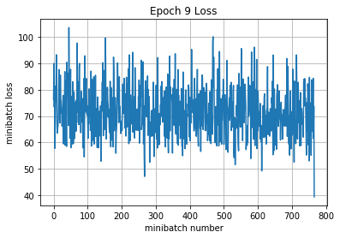

Iteration 6900: with minibatch training loss = 1.38 and accuracy of 0.47

Iteration 7000: with minibatch training loss = 1.06 and accuracy of 0.64

Iteration 7100: with minibatch training loss = 1.16 and accuracy of 0.58

Iteration 7200: with minibatch training loss = 1.46 and accuracy of 0.59

Iteration 7300: with minibatch training loss = 1.24 and accuracy of 0.59

Iteration 7400: with minibatch training loss = 0.953 and accuracy of 0.61

Iteration 7500: with minibatch training loss = 0.831 and accuracy of 0.66

Iteration 7600: with minibatch training loss = 0.822 and accuracy of 0.72

Epoch 10, Overall loss = 1.09 and accuracy of 0.61

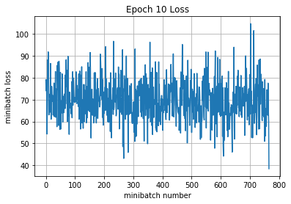

7791.720436096191

Validation

Epoch 1, Overall loss = 1.18 and accuracy of 0.579

Training

Epoch 1, Overall loss = 1.06 and accuracy of 0.628

Validation

Epoch 1, Overall loss = 1.18 and accuracy of 0.579

Test

Epoch 1, Overall loss = 1.18 and accuracy of 0.587

[77]:

(1.1822072303771973, 0.58709999999999996)